GO TO | OHIOCHECKBOOK.GOV/LOCAL
1  Local GOV  & Schools/  School District | 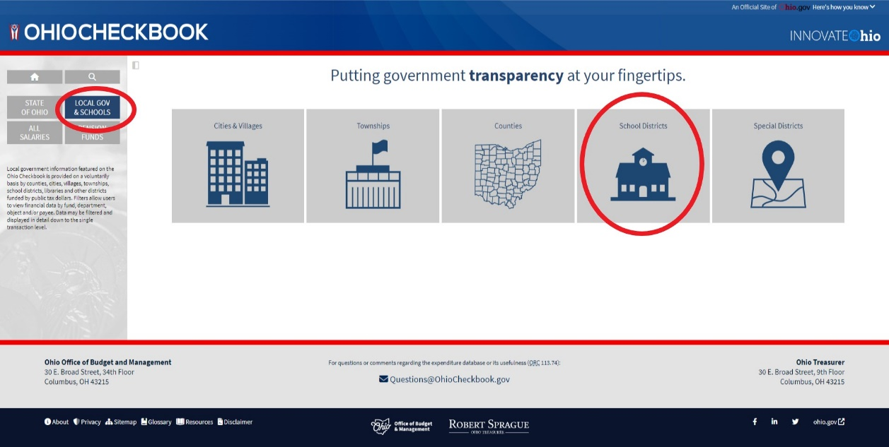
2  Select your school district | 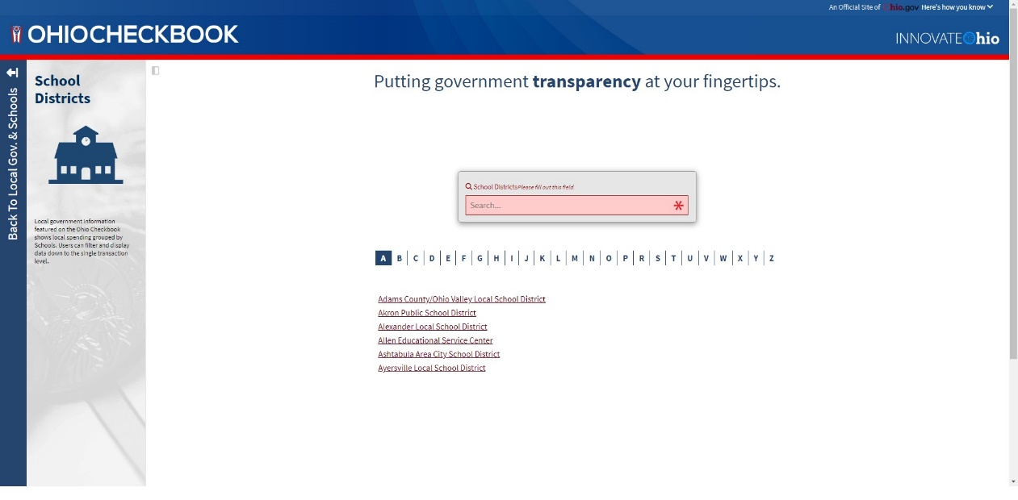
3  View Expense Breakdown | 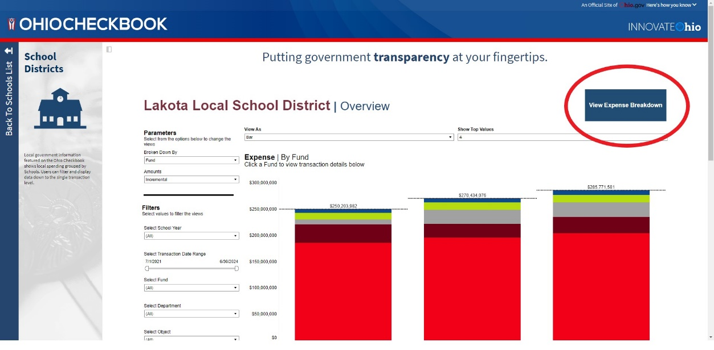
4  Select Payee | 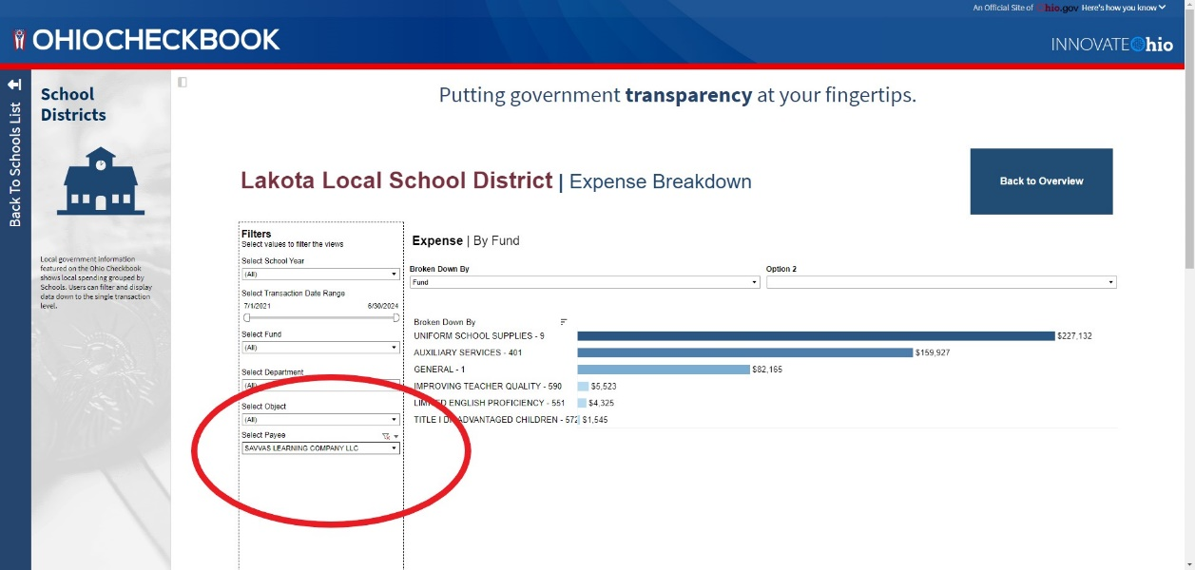

Examples of SEL Publishers/Vendors

3P Learning
7 Mindsets
Accelerate Education
Amplify Education
BrainPop
Child Help
Class Dojo
Committee for Children or Second Steps
Commonlit 360
Curriculum Associates
DBQ Project
Edgenuity
Edmentum
Explore Learning
First Choice Educational Studies
Formative
Gaggle Suicide Prevention
Harmony
Harris School Solutions
Houghton Mifflin Harcourt (HMH)
Illuminate Education
Imagine Learning
Invinite Campus
IXL Learning
K-12 Solutions
Leader in Me
Learning Ally
Learning Without Tears
Liminex Go Guardian
Loving Guidance or Conscious Discipline
McGraw-Hill
McRel International
Membean
Moby Max
N2Y
Naiku Data Management
NCS Pearson Assessments
Newsela
Odysseyware
Open Up Resources
Panorama
Project Lead the Way
Purpose Prep
Renaissance Learning
SAVVAS/Reading With Relevance
Scholastic
Second Steps
Sources of Strength
Studies Weekly
Teaching Strategies
Turnitin LLC
Write Source

